**Enayathulla A**

**Azure Databricks Assignment**

**Cluster creation on already available Databricks:**

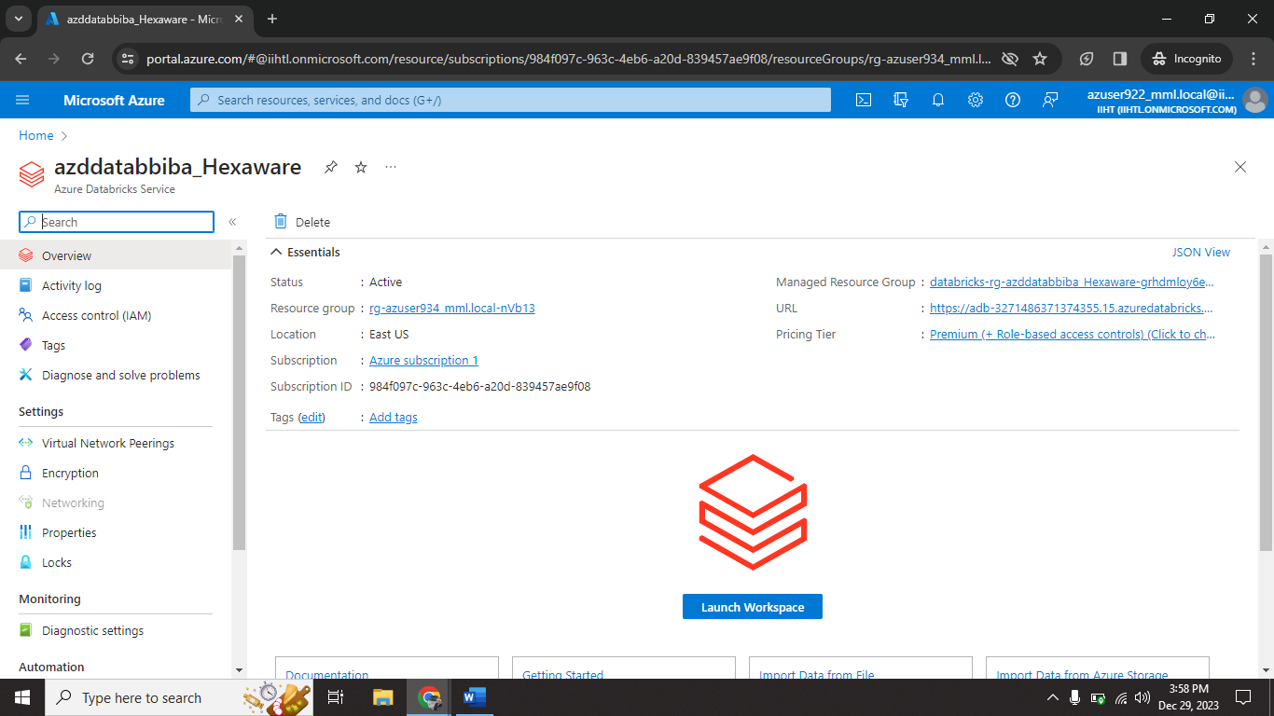

I access this Databricks using my login credential. And I select Launch Workspace.

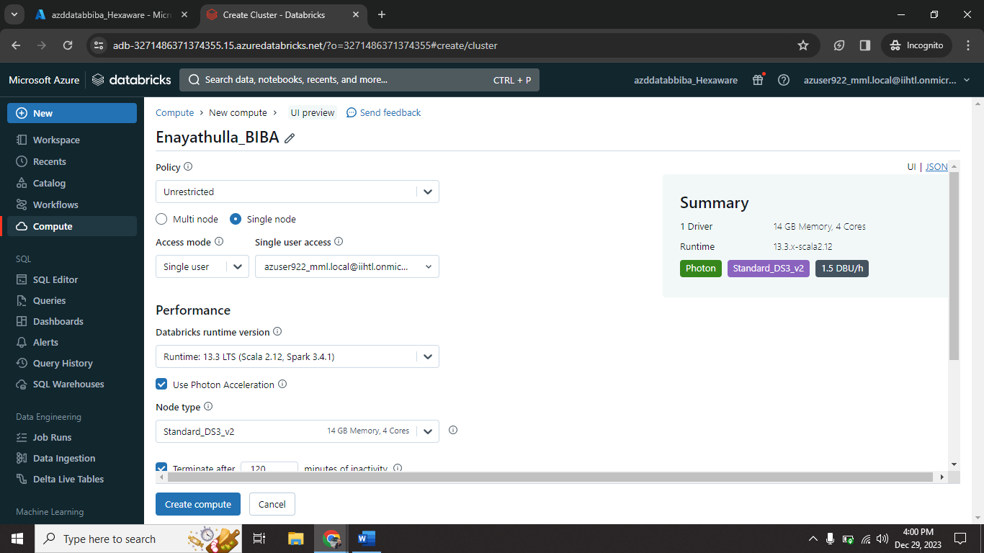

I configure my new cluster (Enayathulla_BIBA) on databricks.

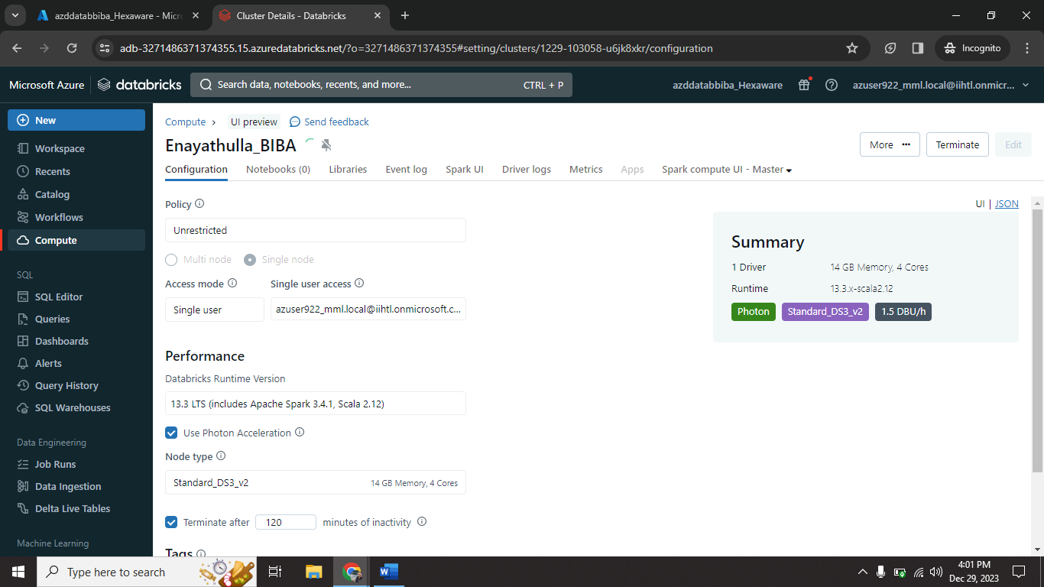

I setup all needed configuration.

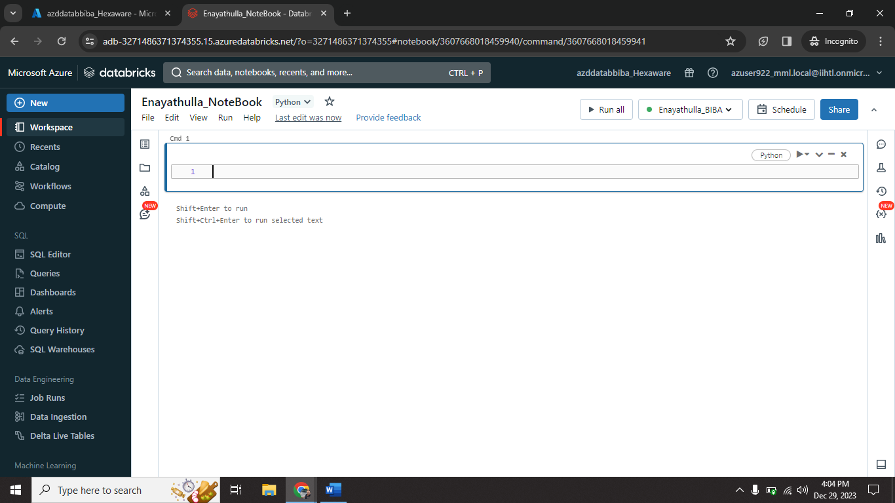

I created one new notebook (Enayathulla_NoteBook) on my cluster (Enayathulla_BIBA).

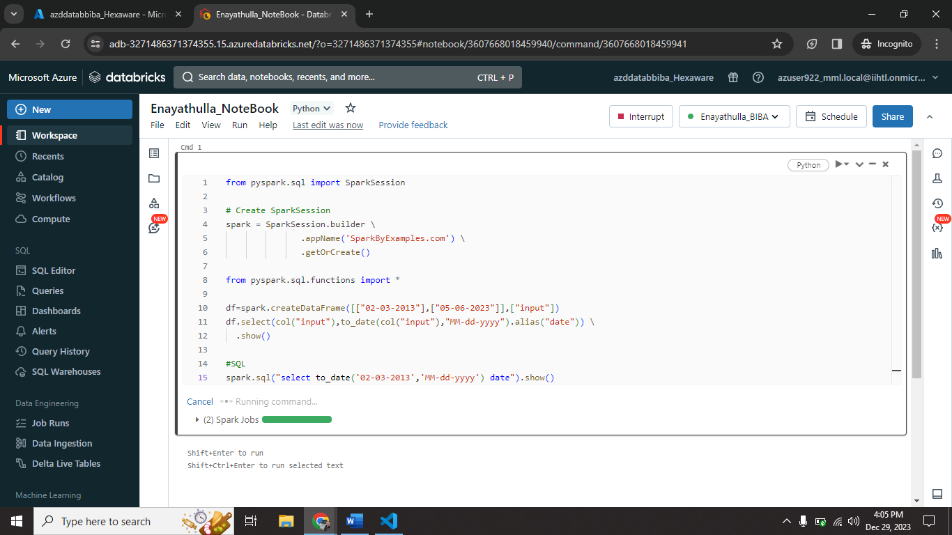

I executed one sample code on my notebook (Enayathulla_NoteBook).

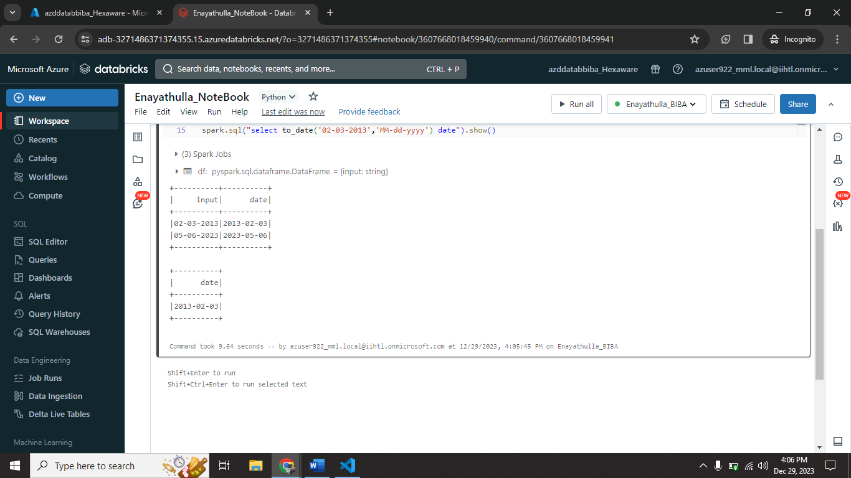

This is the output I got from my sample code.

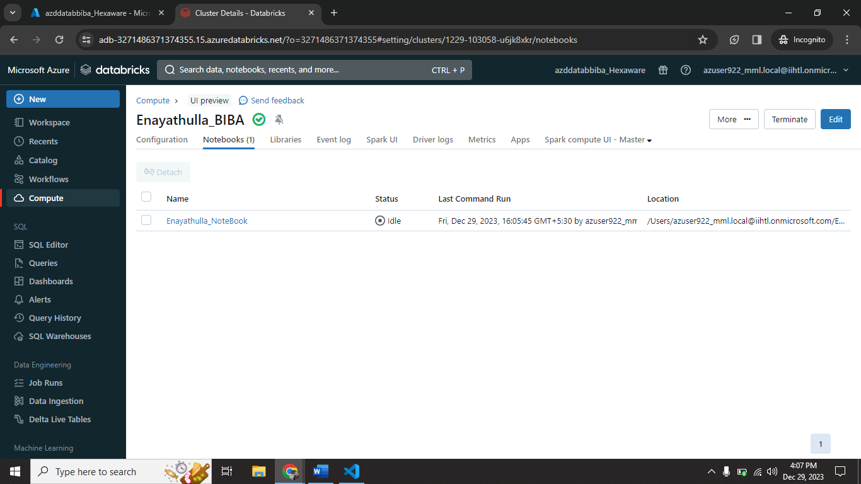

In this tab we saw all available NoteBooks list in that cluster.

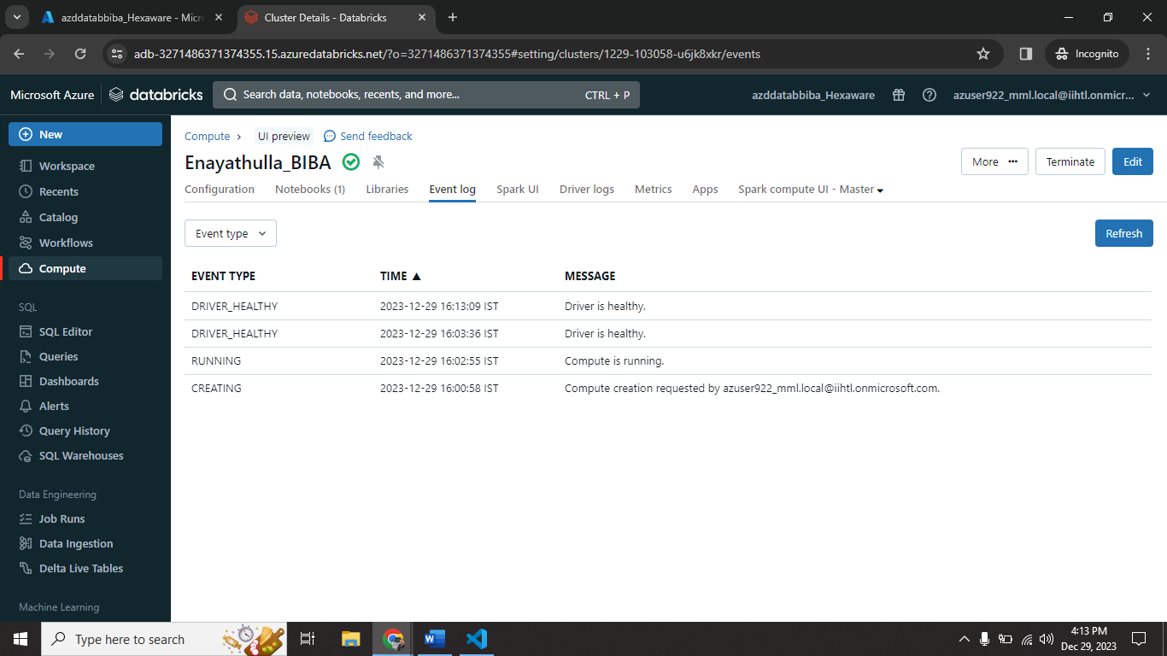

In this tab we saw Event log of the cluster.

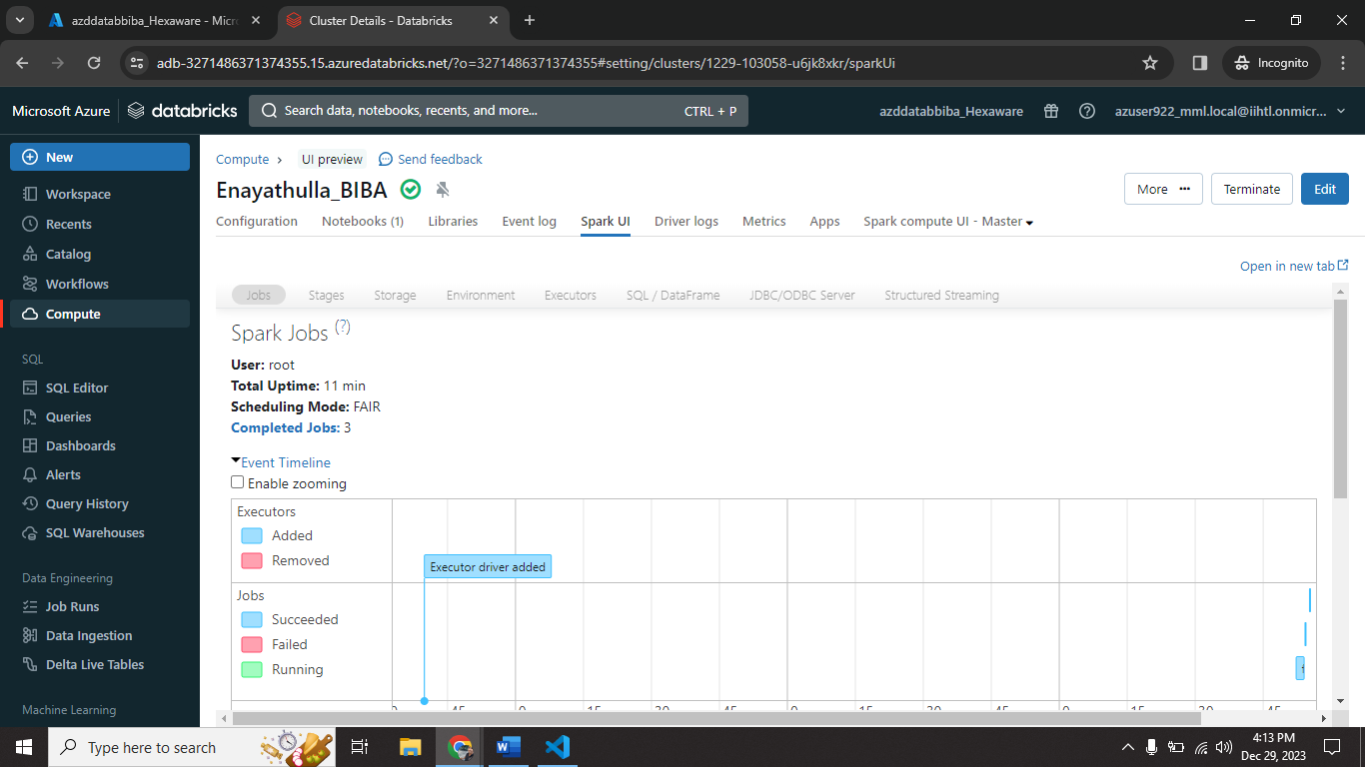

In this tab we saw Spark UI site.

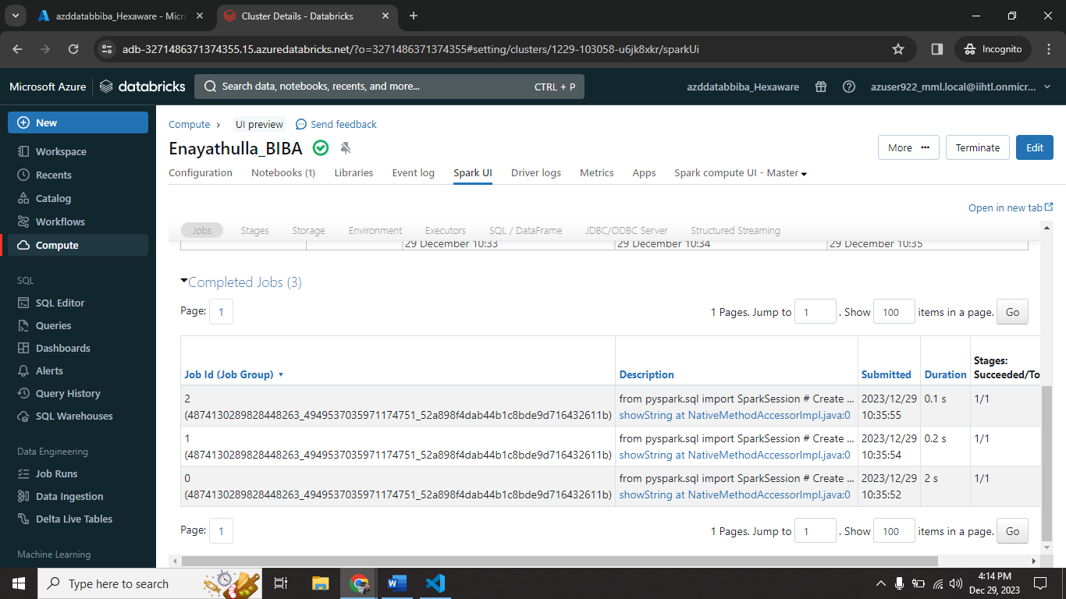

It also shows Job ids and its Job.

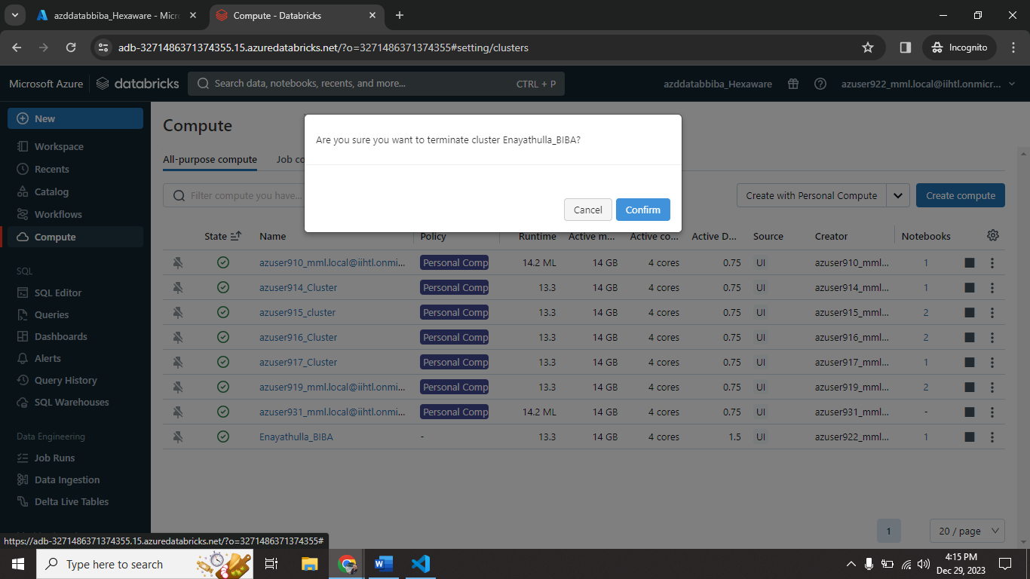

I terminated my cluster (Enayathulla_BIBA) using terminate option.

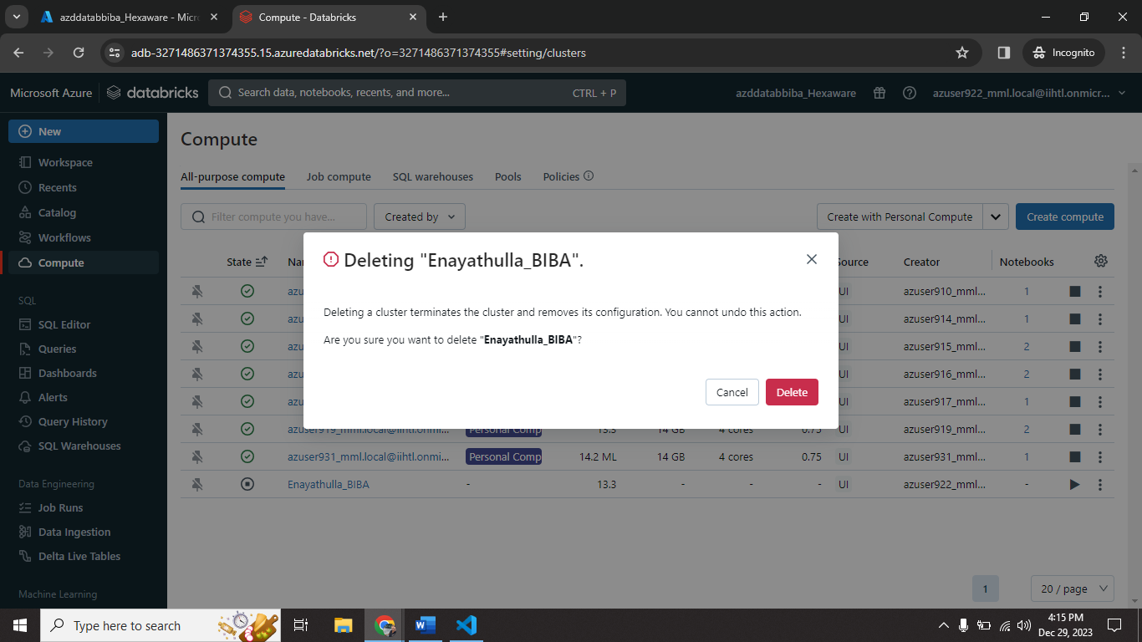

I deleted my cluster (Enayathulla_BIBA) using delete option.

**This is the entire process of cluster creation, process, termination and deletion.**